Michael J. Sullivan
Town Administrator
Jeff Cyr, Chair
Sarah Etelman, Vice-Chair
Christopher Geraghty, Clerk
Andrea Miles
Bruce Forcier

Town Administrator’s Report to the Selectboard
September 28, 2020

Honorable Selectboard,

Please accept the report as an overview of the activities and developing issues occurring in and around Town Hall over the past couple of weeks.

COVID 19 Update
Here is some data on COVID 19 trends specific to South Hadley. The BioBot data indicates that the RNA incidence remains very low, which is great news!
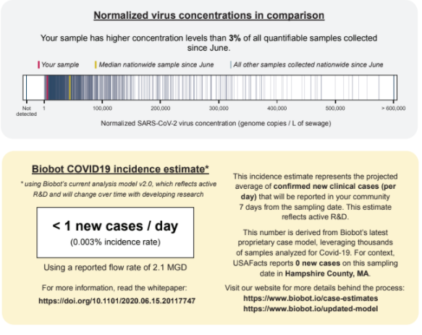
The fourteen-day positivity rate remains very low and the number of confirmed cases over that period is at four as of Sept. 16, 2020. While trends remain very positive for South Hadley this is no time to take our collective attention off of those basic rules - stay home, cover your face, use social distancing when possible, and wash your hands often!

LBOH Count - Events Per Disease and Classification in Jurisdiction
Classification: confirmed,contact,probable,revoked,suspect
Event Dates from 03/01/2020 to 09/30/2020
Jurisdiction(s) selected: SOUTH HADLEY
Jurisdiction(s) used for report: SOUTH HADLEY
The report contains confidential information. The data are current as of 09/29/2020 and are subject to change.
Disease | Status | Num of Cases
Novel Coronavirus (SARS, MERS, etc) | CONFIRMED | 217
Novel Coronavirus (SARS, MERS, etc) | CONTACT | 218
Novel Coronavirus (SARS, MERS, etc) | PROBABLE | 9
Novel Coronavirus (SARS, MERS, etc) | SUSPECT | 3

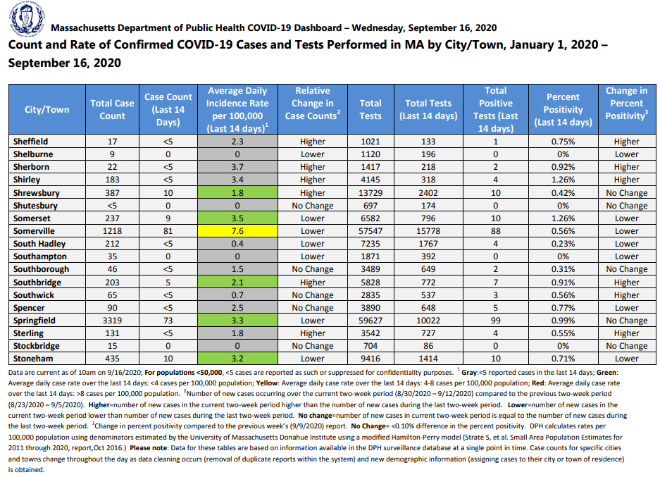

Halloween CDC Advisory
https://www.cdc.gov/coronavirus/2019-ncov/daily-life-coping/holidays.html#halloween
There has been a great deal of media attention about Halloween in respect to COVID-19, as well as flu season. The above CDC guidelines give sound advice to adjust traditional Halloween events to stay safe.

Halloween is an organic event for the most part and has little intersect with bylaws or government edict. Yes, there have been snowstorms or other weather events where local government has cancelled or postponed “trick or treating” with little authority to make such a proclamation and often with limited success in getting compliance.

The Town of South Hadley would encourage everyone to use common sense when planning or attending events. We would suggest you first consider staying home and creating new traditions safely, as suggested in the CDC guidelines. This may include family events with a Halloween theme, though you may want to invite others through virtual means to partake in the activities. You could use all the Amazon boxes you have been collecting to build a ghost town!

Sending “treats” in advance from trusted sources, or that you prepare, to those who may enjoy them may be fun. If you are going to trick-or-treat in a traditional matter, no matter what anyone suggests, please be respectful if someone’s lights are out or otherwise have clearly indicated they are not participating. Respect those wishes. If you are aware of someone who may be in the “at risk” category, avoid them as well. Wearing a mask should be common, but make sure you are wearing a cloth mask which can catch droplets underneath. Do not share masks. As is always the case, discard packaging which may have been breached or ones which are not secure.

Common sense is the greatest tool ….so you may want to avoid bobbing for apples!

Hunting Season
Hopefully everyone is aware hunting season is upon us. We ask people take caution when enjoying the woods at this time of year. Wearing bright orange vests or outwear is advisable.

There is a large parcel of land in between the Town Farm and the Batchelor Brook portion of the River to Range Trail off of Route 47 which is open for hunting and is stocked with types of bird which are allowable to hunt by US Fisheries and Wildlife, so we encourage a heightened sense of awareness at this time in that area.

It should be noted that the vast majority of hunters are responsible and practice safety measures which keep hikers and hunters alike safe, but just being that much more cautious will benefit both parties.

New Phone System, Zoom, Online Reservations,
There have been several communication changes in progress all meant to better serve the public more effectively.
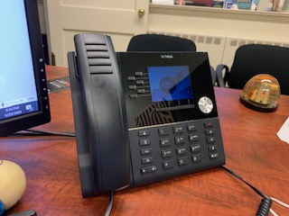
The long-awaited phone system has finally arrived. We are still all learning the different features and beg your patience when you call. We have all gotten new extension numbers, but if you know the old extension add a “6” in front of the other three numbers and it will likely get you to where you wanted to go.

There were developer delays and issues to work out with SHELD, but in all cases it ended up getting us a better system. I would like to especially thank IT Coordinator James Doolittle as he worked diligently on this project and was more frustrated than any of us at the glacial speed it moved. But is in now and we thank you, Jamie!

We also have moved from using Google Meeting to Zoom for remote public meetings and internal meetings in many cases, as well. After a group reviewed the different platforms in June and July, and made recommendation to the SB in August, we are up and running in September.

Executive Assistant to Administration Kristin Maher, Cable Studio Director Dan Pease and IT Coordinator Jamie Doolittle all teamed up to develop policies, become Zoom Masters and generally troubleshoot the new platform. There is still much to learn and to offer for training, but we can start offering Zoom to various boards and commissions. Watch for it to come to a screen near you!

Bookeo is a platform we are presently looking at to integrate into our collection of online features. The first way we would use the new feature would be at the Transfer Station. It will allow the booking of more appointments and a more fluid way to pay for items. The in-house system we are presently using did us well for the initial period and as we understood our internal capacity. But, as requested we need to expand the service and will hopefully be announcing plans to do just that in the next few weeks.

Diversity & Inclusion Project(s)
This project continues under the direction of the Deputy Town Administrator, who, among other responsibilities, oversees human resources. We both feel strongly that having managers and staff exposed to conversations about equity whether gender, race or economic including the challenges and success is critical to our growth as an organization

The Massachusetts Municipal Managers Association has asked me to be part of a sub-committee to find ways cities and towns can attract, retain, and promote a qualified diverse work force including in respect to police departments. The recommendations will look at barriers, such as education, race, gender, and awareness when it comes to municipal careers of all kinds. I look forward to how that effort may positively affect help the municipal complex in South Hadley.

Fall Leaf Pick-up
Thank you to DPW Director Chris Bouchard for his efforts at the DPW. He has a done an outstanding job staying ahead of the tidal wave of change in the tsunami of challenges we have faced in 2020.

Most recently Chris has worked out with Republic Services two leaf pick-ups to assist residents this fall. From Oct. 26 through Nov. 20 you may put your leaf and yard waste out in the large paper leaf bags (no plastic) or open containers. Branches will be picked up, but must be cut in four-foot sections, tied up and should not exceed thirty-five pounds.

Messaging Board
You will be soon seeing some Emergency Management Department messaging boards placed in various locations to assist in messaging. The primary function will be to communicate basic safety messages to the public and directives during emergencies but may be used in a limited manner for other municipal messaging. The Emergency Management Director secured grant money for their purchase. I believe they will be helpful in various ways well into the future.

Respectfully submitted,

Michael J. Sullivan
Town Administrator, South Hadley

