Michael J. Sullivan
Town Administrator
Jeff Cyr, Chair
Sarah Etelman, Vice-Chair
Christopher Geraghty, Clerk
Andrea Miles
Bruce Forcier

Town Administrator’s Report to the Selectboard
Nov. 18, 2020

Honorable Selectboard,

Please consider and review the information presented in this report. Thank you for your attention, patience, and leadership!

COVID 19 Update

In plain speak the trend for the Commonwealth is terrible news and is equally challenging for the Town of South Hadley with 50 new cases when you combine confirmed (21) and contact (19) categories. This is the largest increase of the entire pandemic. There was one additional death reported last week

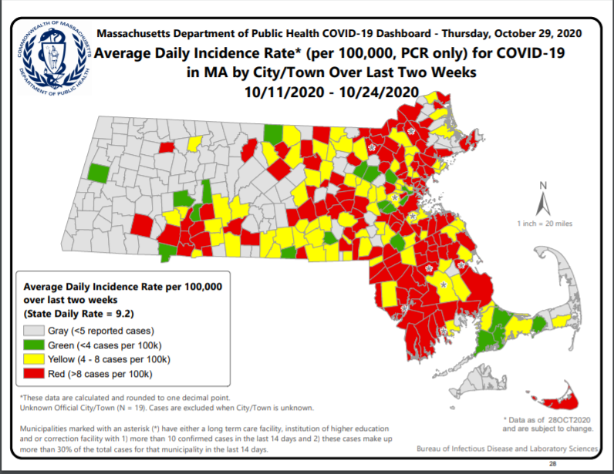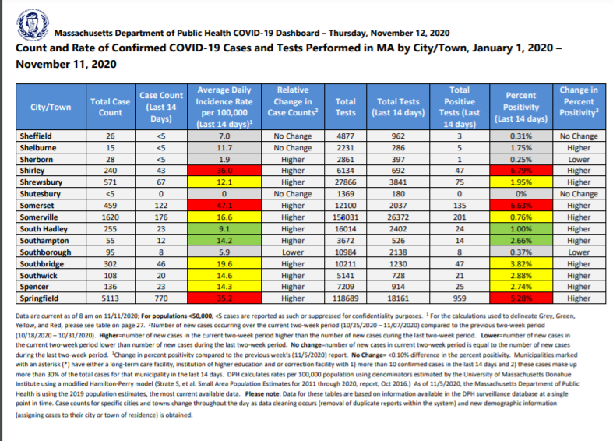

The above map shows how “red” the Commonwealth has become in terms of the two-week trend. If you look at South Hadley we are surrounded.

Below, in blue and italicized, I have copied the latest change to the guidelines determining whe a community would rise or fall to a different color-coded community.

It will be more difficult in the future for South Hadley to become a “red” community, however, as I have mentioned prior, some of that is due to the fact that South Hadley has a higher number amount of testing (a good thing) due to MHC protocols for students and staff. Order #56 and other information is on our website as well as the state website.

Order #56
Rules effective November 6, 2020
For the purposes of COVID-19 Order No. 56, prior to November 6, 2020, a community shall be designated “red” in the weekly municipality data published by the Department of Public Health (DPH) if the community has more than an average daily incidence rate of 8 cases per 100,000 residents in the weekly report. Communities not meeting this threshold are deemed either yellow, green or grey.
Effective November 6, 2020, a community shall be designated “red” in the weekly municipality data published by DPH if the community meets one of the following metrics in the weekly report:
- The community has a population size under 10,000 and had more than 25 cases;
- The community has a population between 10,000 and 50,000 and had an average daily incidence rate of 10 or more cases per 100,000 residents and a test positivity rate of 5% or more; or
- The community has a population over 50,000 and had an average daily incidence rate of 10 or more cases per 100,000 residents and a test positivity rate of 4% or more.
Communities not meeting the above threshold are deemed either yellow, green or grey.
Moving from 3.2 to 3.1
A community that qualifies as a “lower risk community” shall cease to qualify as a “lower risk community” if the 3 most recent weekly reports published by DPH indicate that the community is designated red in each of the 3 reports.
Upon meeting the above criteria the community must comply with the rules associated with Step 1 of Phase 3, effective the Monday after the data is published.
Moving from 3.1 to 3.2
A community that does not qualify as a “lower risk community” shall qualify as a “lower risk community” if the 3 most recent weekly reports published by DPH indicate that the community is designated yellow, green or grey in each of the 3 reports.
Upon meeting the above criteria, the community may move into Step 2 of Phase 3, effective the Monday after the data is published.

Below is the most recent data for the virus and it is quite evident by any measure the presence of COVID 19 in the Town of South Hadley is on the rise with no signs of abating. With Thanksgiving a week away, we are pleading with you to use caution when interacting with others outside of your normal social sphere. This is a critical time for all of us.

LBOH Count - Events Per Disease and Classification in Jurisdiction
Event Dates from 03/01/2020 to 11/18/2020
Jurisdiction(s) selected: SOUTH HADLEY
Jurisdiction(s) used for report: SOUTH HADLEY
The report contains confidential information. The data are current as of 11/17/2020 and are subject to change.
Disease | Status | Num of Cases |  |  | 11/10/2020 |  | 11/2/2020 |  | 10/27/2020
Novel Coronavirus | CONFIRMED | 273 |  |  | 252 |  | 236 |  | 229
Novel Coronavirus | CONTACT | 282 |  |  | 253 |  | 242 |  | 231
Novel Coronavirus | PROBABLE | 13 |  |  | 12 |  | 10 |  | 9
Novel Coronavirus | SUSPECT | 11 |  |  | 11 |  | 9 |  | 8

Construction Soil Landfill Acceptance

At the Nov. 10 South Hadley Selectboard meeting there was an initial discussion about a proposal to exploit some of the space at the landfill. While this idea was brought to the Selectboard by a developer working in the disposal industry, it has in no way endorsed or supported by the Selectboard at this time.

There was conversation about the revenues it may provide, but there was also voice given to traffic concerns and possible environmental impact. The public is strongly encouraged to go to the link below and use the Google Form to ask questions and make comments about the project (proposal attached to the form).

https://docs.google.com/forms/d/1Dqtl-WQfriUrTOvEzf1bb5IEswnZNm52H-ROCDy0OBc/edit

The Selectboard encouraged the proposer to go virtually to other committee meetings such as Conservation, Health and Planning to continue the public outreach. There would be a significant investment by the proposer in way of a feasibility study. To ensure the effectiveness of a study and to inform the Selectboard if they would like to go forward on the project, it is critically important questions are asked early as opposed to later in the process.

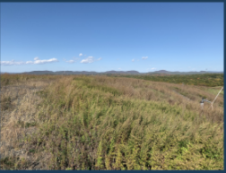
The costs associated with opening, including but not limited to the feasibility study, the state permitting, local planning or permitting, surveying or any other reasonable cost, would be borne by the proposer, not the town.

Kip Foley of Closure Management has worked on similar projects across Massachusetts and other northeastern states. He suggested the project may deliver a million dollars in revenue to the Town of South Hadley. However, there are other significant issues which need to be explored beyond the economics, and that was clearly expressed by the Selectboard at the meeting.

MassWorks Grant at Lyman and Newton

Through a great deal of hard work by many including the DPW, District #1 and the Planning Department - especially Richard Harris, a recent $2.7 million grant become a reality for South Hadley.

We greatly appreciate being part of the MassWorks Infrastructure Program and Governor Baker’s recent announcement that we would receive an award from this competitive grant. Equally we are thankful for and to be beneficiary of the advocacy from Senator Comerford and Representative Carey in respect to this funding.
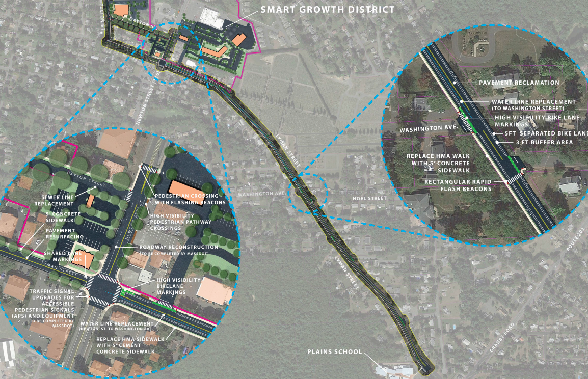

As depicted above, the Lyman and Newton intersection, along with Fulton and Dayton streets, will receive significant improvements including subterranean utilities, sidewalks, bike lanes and signalization as part of this investment and in concert with a Transportation Improvement Project (TIP) slated for 2022 to improve Newton (Route 116) from Ranger to Kendrick.

This is a great opportunity for the Town of South Hadley. MassDOT and the municipality are sensitive to the need to improve safety and traffic flow in this area and will do all they can within the resources to make those improvements during this project.

Please stay safe!

Respectfully submitted.

Michael J Sullivan
South Hadley, Town Administrator

