Michael J. Sullivan
Town Administrator
Jeff Cyr, Chair
Sarah Etelman, Vice-Chair
Christopher Geraghty, Clerk
Andrea Miles
Bruce Forcier

Report to the South Hadley Selectboard – Feb. 25, 2021

COVID 19 Update
As you can see from the table below the COVID 19 numbers are plateauing to some degree. The positivity rate as of Feb. 16 is 1.33%. In the previous 14 days in South Hadley there were 70 positive tests our of 5,268 tests administered over that period (mostly on the MHC campus). So far there have been more than 39,000 tests administered in South Hadley overall.

If you are a math person and look at the chart below you may say, “Wait a minute, That chart says there was only 59 in the last two weeks.” Well, here is the rub - the Commonwealth provides us with the numbers for both sets of data. The local board of health numbers in the chart are Tuesday to Tuesday, and the positivity rate numbers are Thursday to Thursday. We do not know why the two are separated by two days. We have asked but are not privy to the thinking behind the system.

LBOH Count - Events Per Disease and Classification in Jurisdiction
Classification: confirmed,contact,probable,revoked,suspect
Event Dates from 03/01/2020 to 02/24/2021
Jurisdiction(s) selected: SOUTH HADLEY
Jurisdiction(s) used for report: SOUTH HADLEY
The report contains confidential information. The data are current as of 02/23/2021 and are subject to change.
Disease | Status | Num of Cases |  | 2/16/2021 | 2/9/2021 | 2/2/2021 | 1/26/2021 | 1/19/2021 | 1/12/2021 | 1/5/2021
Novel Coronavirus (SARS, MERS, etc) | CONFIRMED | 866 |  | 842 | 807 | 782 | 744 | 705 | 641 | 582
Novel Coronavirus (SARS, MERS, etc) | CONTACT | 663 |  | 648 | 617 | 588 | 560 | 535 | 514 | 496
Novel Coronavirus (SARS, MERS, etc) | PROBABLE | 53 |  | 49 | 46 | 40 | 38 | 37 | 36 | 34
Novel Coronavirus (SARS, MERS, etc) | SUSPECT | 19 |  | 19 | 19 | 19 | 18 | 17 | 18 | 18

We also are seeing data sets in the BioBot suggesting and supporting that the virus is slowing in its spread. However, this does not mean we should abandon all the safety protocols we have been touting. It is actually a good time to redouble our resolve. We greatly appreciate the level of cooperation we overall have gotten in South Hadley. With 24 new confirmed cases over the last week, and schools about to resume in-person instruction, we encourage hyper-vigilance in regard to the pandemic. Hopefully, we have turned the corner.
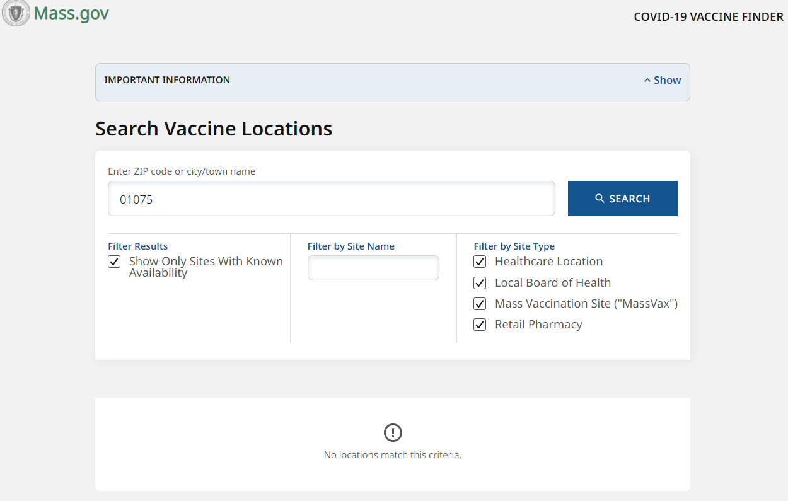
Vaccines

We continue to seek vaccine opportunities for South Hadley residents as expediently as possible. Here is a picture I captured from mass.gov’s Vaccine Finder on Wednesday, Feb. 25 which indicated there was no vaccines available within a 25-mile radius of the 01075 zip code. Thursday morning at 7 a.m., as more appointments are made available every Thursday for Mass Vaccination Sites (Eastfield Mall), I plugged in the information seeking a vaccine. I was told there were 59K customers in line ahead of me and they would contact me via email when my turn came up in the que. At 9:45 a.m. I was informed there were 31,552 people ahead of me and all the appointments for next week were filled and to try again next week.

Mayor Vieau reached out to South Hadley last week and asked if we would be willing to participate in a new vaccination site tentatively set for the Castle of Knights on Memorial Drive. We not only stated emphatically that we were interested, but that we greatly appreciated his outreach. The new site will have to get approval from the Commonwealth. The mayor is in direct conversations with the Governor and Lt Governor and will announce the final plans as soon as they are available. We still are part of the Hampshire Coalition as they are working out details in accordance with some changes being implemented by the state.

We set up a new COA Vaccine Hotline for seniors or people with disabilities to help set up appointments when available at (413) 650-1021. This will allow residents to leave a message or speak to someone if they are not on another call with a resident. They also have a very, very limited capacity to provide transportation. We do encourage all parties to use this only as a final option. If you can get a safe ride from someone else we would appreciate it greatly.

Deputy Town Administrator

As I have discussed with the Selectboard Chair and Vice Chair, I have granted Deputy Town Administrator Jennifer Wolowicz intermittent leave as she serves as the Interim Town Administrator for the Town of Monson. This is an excellent opportunity for DTA Wolowicz and for Monson.

She will be working 24 hours a week in Monson while taking vacation or unpaid leave when necessary in South Hadley to cover 18 hours a week. The additional 8 hours will be on weekends and after her normal working hours in South Hadley. Jennifer will remain available to South Hadley during business hours throughout this period.

If she is offered the full-time position, which is expected to be announced in April or early May, the balance of her work will be reallocated as we begin the process of assessing the needs of the Human Resources Department. The Deputy Town Administrator position specifically will remain unfilled to allow the Selectboard and the new South Hadley Town Administrator to develop a strategy for the future regarding this and other organizational issues.

I am thankful to have had the opportunity to work with Jennifer Wolowicz in South Hadley and wish her well in this new endeavor.

Landfill Annual Report

We have received the 2020 Annual Report on the conditions of the MSE Berm. The stability was one of the concerns prior and during the closure process expressed by some citizens during the discussion about closing in 2014.

The conclusion reached by Tighe and Bond and their associate ARM is the berms are holding up well with the expected level of settling in the middle of the site. This is in relationship to the heaviest amounts of trash being concentrated intentionally in that area. They concluded no further actions or inspections are necessary at this time.

FY 22 Budget

The initial expense side of the budget was revealed at the Selectboard Meeting held on Feb. 16 and will be further discussed at the next meeting on March 2. There also will be a discussion at the Appropriations Committee meeting on Feb. 25 at 6:30 p.m. The relative documents are linked to both the Selectboard and Appropriations page on the town website.

One of the different approaches this year will be the TA recommendation to consider the General Fund Budget separate from additions to stabilization accounts or OPEB. Having those in a separate warrant article should allow more in-depth discussion on both future uses of those funds, but a greater understanding that they are essentially “savings” accounts.

There will likely be some capital projects put forth in another article. The capital needs discussion will begin Tuesday, March 2 at 4 p.m. with the Capital Planning Committee. This meeting will try to cover the most pressing capital needs facing South Hadley.

This is a more difficult year to determine if the information is being articulated effectively given the mediums we are using and the absence of meeting in-person (which I hope is safe to get back to at some juncture). I encourage people to attend meetings, view the recordings and if you do not get an answer at those meetings to please email me the questions and I will do my best to track down answers.

Respectfully submitted,

Michael J. Sullivan
Town Administrator, South Hadley

