Michael J. Sullivan
Town Administrator
Jeff Cyr, Chair
Sarah Etelman, Vice-Chair
Carol Constant, Clerk
Andrea Miles
Christopher Geraghty

Town Administrator’s Report to Selectboard
July 13, 2021

Plains School Landscaping
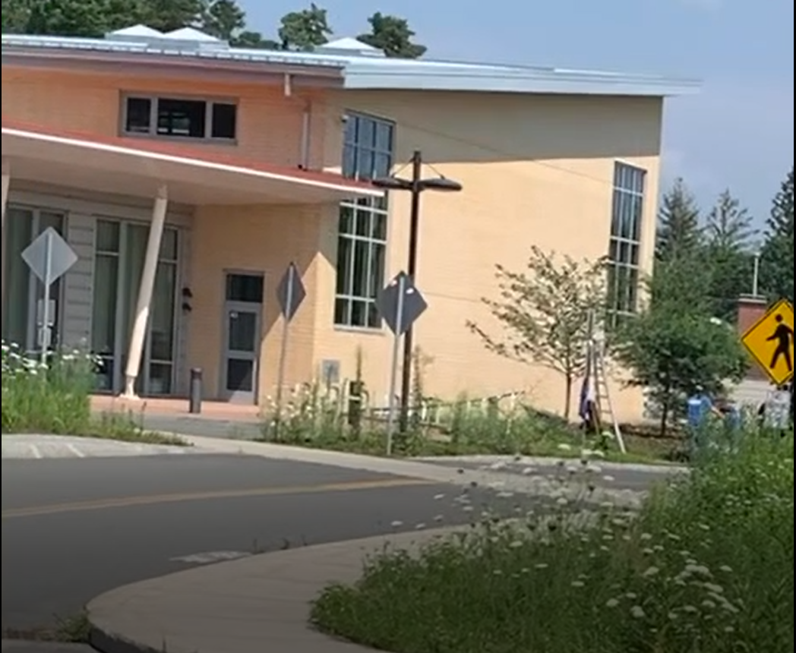
There has been both awareness and thoughtful discussion about the landscaping at the Plains School and how to address it in the present and going forward. Like so many things in our society, community and our everyday lives, the issue is more complex than is captured in an angry Facebook post or a Tweet.

The history of this issue goes back to the design and subsequently the construction of the school. During those processes it was expressed by the DPW Parks Division, the Selectboard and even members of the Plains School Building Committee about the landscape’s complicated lay-out.

Early in the design and construction was a determination that the various islands, special grasses, undulating hills, retention bio-swales, interior courtyards and select native plantings was well beyond the capacity for the Parks Department be able to reasonably maintain. This is from staffing, training, and equipment assessment of the need.

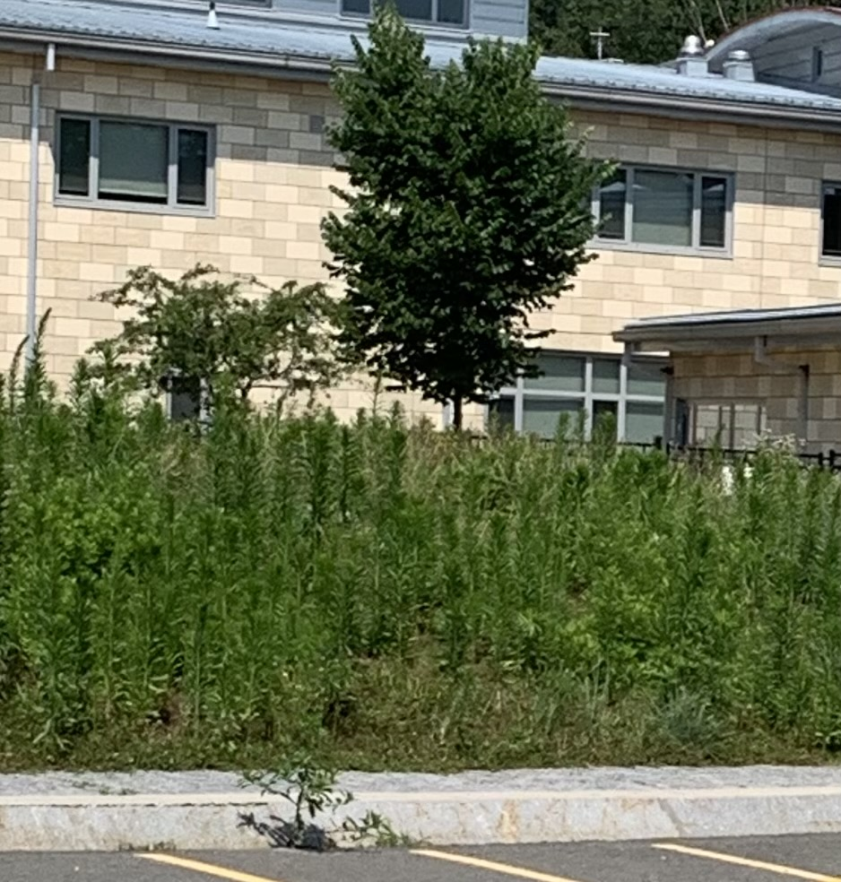
If you look at the ball field closest to the school, you will an impressive and successful maintenance plan in full display. This design is well within our expertise, staffing and available equipment. It also is within our budgeted staff hours. This field is part of the impressive work the Parks Division (three staff and a working supervisor) does at other municipal properties, including but not limited to Buttery Brook, Police Station, Town Hall, Beachgrounds and Landers Field. All these properties would likely suffer if we would reallocate staff to the intensive and complex landscaping needs, at Plains School.

The Schools Superintendent acting impressively swiftly to this issue in the first few days of his tenure engaged a landscaping firm to immediately start to address the problem. Mountain View landscaping was on site Wednesday July 7th and was able to clear the area closest to the entrance on the right side. They had a three-member crew for about four hours with equipment and tools appropriate to the task. I estimated that the clearing represented about 15% of what is needed to be done and will take another week or so to do the remaining work.

The cost is approximately $20K for the landscaping project which seems like a lot but considering the project complexity and the fact it is a seasonal issue it is far less expensive than adding staff. Contract services for a variety of reasons is becoming far more needed and effective then the old way of just adding staff. The municipality no longer paves streets or installs sidewalks as it did in the 1950s, it no longer has an electrician, carpenter, or plumber on staff, much of the tree removal is done through contractors and we do not pick up trash (some say neither does Republic). While contract services are not always the answer, given the cost, safe standards, advanced equipment, and training required for many municipal tasks today it goes without saying contract services are the way of the future.

If the Town of South Hadley were to hire another three-man crew to address the $20K clean up issue it would cost about $180,000 annually with benefits. We would have to get well qualified and trained people, make a year-round full-time commitment to an intensely seasonal issue. While the contract route seems more expensive that is not always the case.

COA Electric Vehicle

We were happy to hear through the hard work of Representative Dan Carey the request to have a state budget allocation for FY 22 to purchase an e-vehicle for the Senior Center was restored to next years budget. This will allow the Senior Center to provide transportation while reducing the municipal carbon footprint. We will still be using the vans when there are accessibility requirements or when it makes logistical sense.

The charging station at the new Senior Center on Dayton Street was already part of the design and will be able to serve this vehicle, as well as others as we encourage more citizens to consider electric vehicles. The breakthroughs in battery technology and the reduced service needs, beyond the clean emission is the future. Thank you, Representative Carey and Senator Jo Comerford, for your advocacy for South Hadley and the environment.

On the energy efficiency front, the PD is in the process of converting some interior lighting to LED, ordering some more efficient hybrid cruisers and Town Hall has installed additional motion detectors in hallways and common areas to ensure lights go off quickly upon the area being vacated. These are small, but important steps towards reducing our use of power. We also are looking at methods and strategies for other buildings to impact energy usage. There is on-going conversations with Beacon Strategies, The new Planning Director and other departments to seek cost effective savings throughout the organization.

CDBG Supplemental Funds

We have begun the process of applying for Community Development Block Grant (CDBG) Supplemental Funds for design of sidewalks and reviewing right of ways on Center, Graves and Warner Streets. If successful in getting the design funds, it will allow us to complete the lay-out with both construction and temporary benchmarks, define the right of way and add accessibility ramps. After Phase I we would be well positioned for more funding relative to the reconstruction of the roads and sidewalks in the area.

This project is intended to be ready for FY 23 and there would be a Phase II to include North and South Streets following this project. While the hope is much of this is eligible for federal funding and this is a forward-thinking step by the Town of South Hadley to make this investment in this neighborhood as it was recently determined to be an Environmental Justice Area by the Commonwealth and the federal government.

We are also looking at increasing the Housing Rehab Program through CDBG, the challenge with that program right now is finding material and contractors available to take the work and or be qualified through the program. Presently there are 12 individual homes being rehabbed through the plan in SoHa. Please contact Shirley Stephens at Pioneer Valley Planning Commission to see if you qualify and apply for the grant program Sstephens@pvpc.org .

COVID 19 Update “Plus”

Although we, like the Commonwealth, have moderated our reporting of the virus, in no way does it mean the Town of South Hadley and the Health Director Sharon Hart or her staff have abandon any attention to the pandemic. They continuously monitor and work with state agencies to stay abreast of any developments in practice or in terms of data.

Disease | Status | 7/13/2021 | 6/28/2021 | 6/15/2021 | 6/8/2021
Novel Coronavirus (SARS, MERS, etc) | CONFIRMED | 1054 | 1052 | 1052 | 1052
Novel Coronavirus (SARS, MERS, etc) | CONTACT | 857 | 855 | 855 | 855
Novel Coronavirus (SARS, MERS, etc) | PROBABLE | 93 | 93 | 93 | 93
Novel Coronavirus (SARS, MERS, etc) | SUSPECT | 30 | 29 | 28 | 27
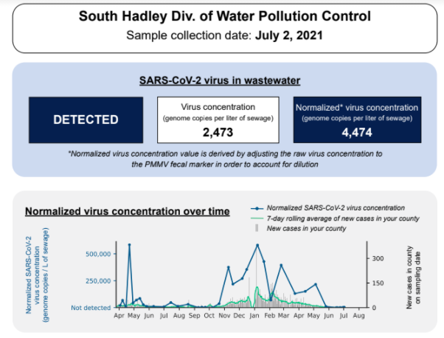
As the recent BioBot data would indicate we are seeing very low concentration of the virus at the Water Pollution Control Facility (formerly known as the WWTP).

This does indicate we are making progress in controlling COVID 19 in South Hadley. Thanks to the public’s effort. It should be noted we are no where near done with this health challenge.

We are very aware of the need to develop safe practices to avoid outbreaks and protect the most vulnerable populations in the community. We ask that all residents consider vaccinations and practice the all too familiar protocols when necessary.

The Health Department has reallocated some of their attention to issues around heat waves, mosquitos, ticks, and other warm weather issues. We encourage every citizen to learn more about how they should protect themselves from these summer threats.

There is an expectation when this rain ends a week later, we will see a substantial increase in the mosquito population. Avoiding dawn and dusk outdoor activities, wearing long sleeves, dark clothing, checking regularly for ticks, removing standing water from around your house and other tips can be seen on the website (Health Department).

The Health Department and Recreation Department is working in tandem to provide residents, coaches, young athletes with information about the importance of staying hydrated, using sunscreen and bug repellent. They have a limited number of safety kits available to the public with information and some for the afore mention items. Please go to the Recreation Department web page or call them at 413 538 5017 ext. 6131 for more information on the initiative.

Town Hall Re-opening

Like most of our experiences going into the pandemic and now trying to return to some semblance of normalcy we have experienced glitches. Please accept our apologies and be confident we continue to work to improve service delivery, explore new approaches and to retain learned efficiencies. With service portals including open to the public hours (Tuesday, Wednesday, Thursday 10 AM until 2 PM), appointments for some departments, curbside, on-line platforms, and other innovations we feel confident we can meet the public need.

The Selectboard will be in-person with the attendees Zooming in remotely this evening at 6 PM. We will be testing out some new technologies, so we ask for your patience. As we work through the kinks, we hope to create a portable system which will be able to be set up easily at other locations for future use and use by other boards and committees.

This week we averaged about two visitors per hour, as most of the various processes have gone to one platform or another. We will continue to assess needs, including considering some seasonal needs (voter registration, tax billing cycles, program sign-ups etc.) which may require expanded or adjusted hours. If you need some service in an emergency, please call and we will do our best to accommodate the request within our capability and availability.

Our normal business hours remain the same Monday through Friday 8:30 to 4:30, however with childcare challenges, more acute sick protocols, and all the other staffing issues we face regularly we always suggest calling ahead. We also will us the USPS method if the request warrants it, we encourage people not to wait until the final day to solve a problem as it just makes it more frustrating when it cannot be done.

New TA Selection

Congratulations to the South Hadley Selectboard for finding an outstanding candidate for your next Town Administrator! You continue to assemble a team of superstars and having someone of Lisa Wong’s caliber lead the way paints a great future for the Town of South Hadley.
Ms. Wong is a highly regard professional with experience in communities quite diverse in their demographics and policies. She is part of numerous state and regional associations for Winchester which is the town she presently serves. I feel confident Lisa Wong is very capable to bring South Hadley to the next level. Best of luck to all!

Respectfully submitted,

Michael J. Sullivan
Town Administrator, South Hadley

