Lisa Wong
Town Administrator
Jeff Cyr, Chair
Sarah Etelman, Vice-Chair
Carol Constant, Clerk
Chris Geraghty
Andrea Miles

Town Administrator’s Report to Selectboard
March 1, 2022

Administration, Finance and Operations
- The Capital Planning Committee will begin meeting with departments to review their five-year capital plans on Mondays, March 14, 21 and 28 from 5-7pm.
- The Mass Municipal Association is urging legislators to increase Unrestricted General Government Aid by 7.3%, not the 2.7% that is in the Governor’s budget.

Community Highlights
- The Town Hall hours open to the public have been expanded to 8:30am to 3:30pm Mondays through Thursdays starting March 1.

Planning and Economic Development
- The Town has submitted two REDO grants to the Western Mass EDC to fund projects outlined in the Local Rapid Recover Program document. The applications include $70k for a façade improvement program in the Falls and $35,000 to work with local businesses to install flexible outdoor furniture (removable) and games to draw people to gather within the Village Commons District–e.g. chairs, picnic tables, planters; host public art and seasonal offerings within the Village Commons District; and add free mesh wifi system for the Village Commons District to enable access to the internet by people of all incomes.
- The Pioneer Valley Planning Commission has awarded a technical assistance grant to the town for the purposes of exploring the formation of a Housing Partnership Board, developing a framework for creating an Affordable Housing Trust, and conducting public education programing and workshop series about housing affordability.
- The Small Business Grant Program funded through the ARPA legislation in December just launched. The application may be accessed at: empoweringsmallbusiness.org. It will be open until April 4, 2022. The program is organized around two buckets:
  - $50M is available to small businesses impacted by COVID-19, especially businesses that focus on reaching markets predominantly made up of socially and economically disadvantaged and historically underrepresented groups, and those owned by minorities, women, veterans, individuals with disabilities, or those that identify as part of the LGBTQ+ community.
  - The other $25M is restricted to those businesses that have not previously received financial relief from MGCC’s previous relief programs.

Public Health
- 26 active confirmed cases as of 2/22. This brings the total number of confirmed cases to date in South Hadley to 3001.
- The Massachusetts Department of Public Health (DPH) reminded residents that free treatment options are available that can be used to prevent severe illness and hospitalization from COVID-19. Several treatments, including monoclonal antibody infusions and oral therapeutics, are widely available across the Commonwealth. Treatment is available for people who are at increased risk of severe disease, test positive for COVID-19 and have any symptoms, even mild ones (such as runny nose or cough). Residents who think they may be eligible and have questions on if treatment is right for them should contact their medical provider or call the COVID-19 Self-Referral Treatment Line operated by Gothams. The Gothams call line is a free resource that can help refer individuals to sites for monoclonal antibody treatments. These treatment options have been authorized by the FDA for the treatment of COVID-19 in individuals ages 12 and over who are at higher risk for severe COVID-19 illness. Referrals for monoclonal antibody treatment can be provided by the Gothams call center by calling (508) 213-1380, Monday – Saturday 8:00 a.m.-6:00 p.m., or by an individual’s healthcare provider.
- BioBot data has been showing a general downward trend in February, with the latest figures from a February 18th sample.
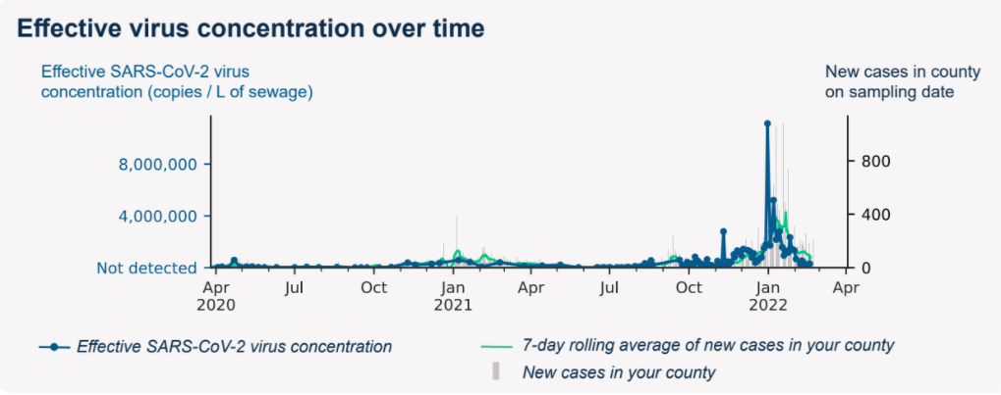

Public Safety
- In order for the South Hadley Police Department to be recognized as an accredited agency, there will be an on-site assessment by the Massachusetts Police Accreditation Commission. Gaining state Accreditation is a highly prized recognition of law enforcement professional excellence. A team of assessors is scheduled to arrive on Tuesday March 8th, 2022 to begin the two day assessment. The team is comprised of five local law enforcement officials, all of whom have been specially trained by the Commission to conduct the assessment.

Public Works
- The snow and ice budget of $101k has been exceeded with $137k in expenditures so far, not including the Febr 25 storm events.

